SchoolTrack User Guide Documentation

# STUDENT USER GUIDE

**Student Login Page –** If a student user has already created an account. They can log in here, using their credentials. If not, they can click “Create New Account”.

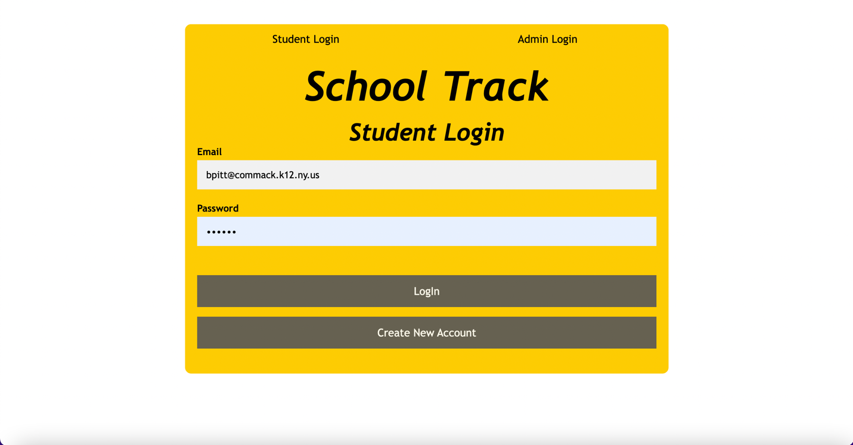

**Student Registration Page** - When the student user creates a new account, they are prompted to input their information. *Note – the email they enter must be a Commack email to be valid*

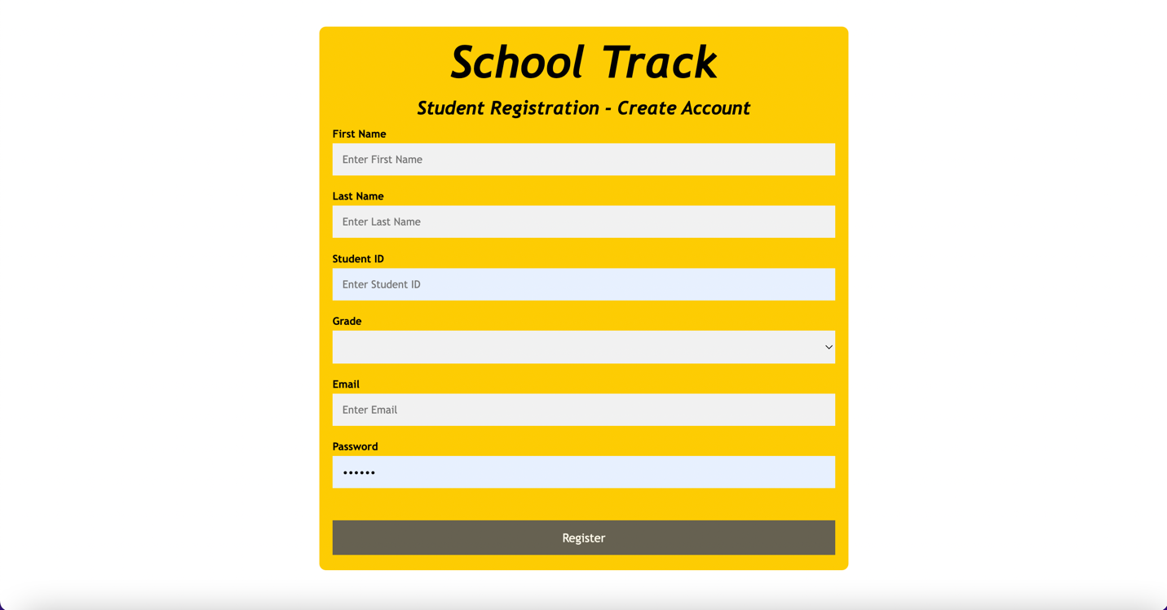

**Student Profile Page** - Once the student user logs in or registers, they are taken to the student profile page. On the left, it says the students name, student ID, grade, and the number of points they have. On the right, there is a list of all the events that a student has attended so far including the event name, date, and points. This sample student is in 12th grade and has 20 points. The student can also see which events they are checked in to.

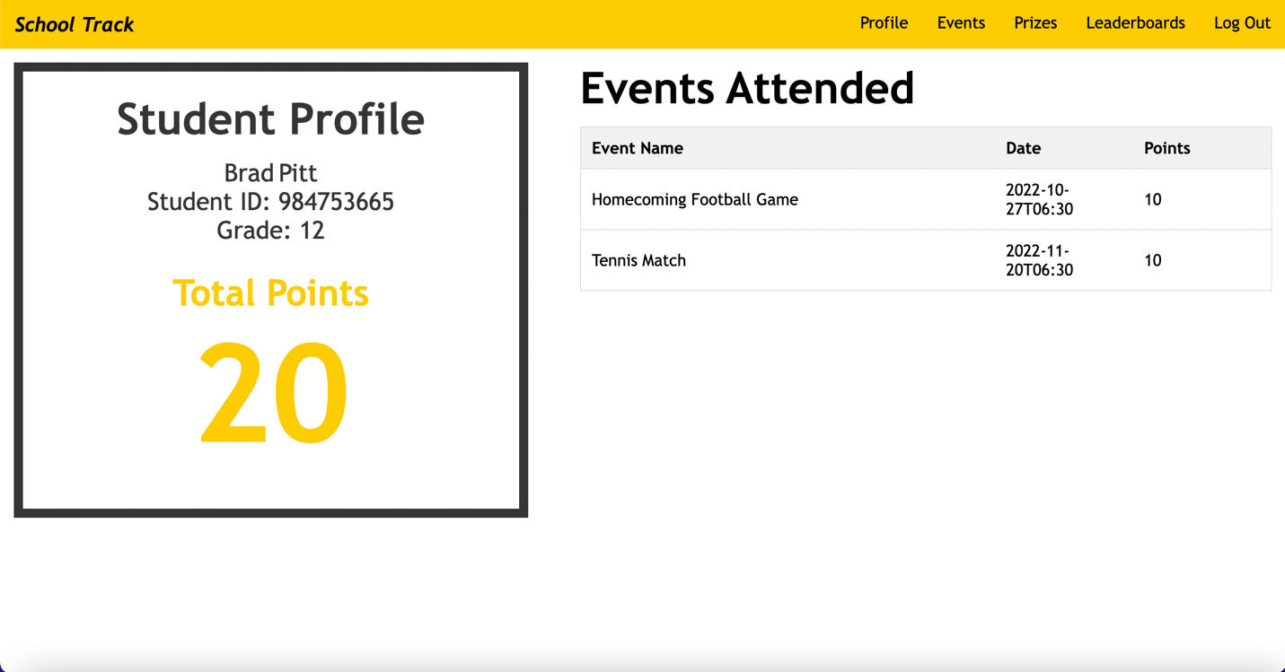

**Student Event Page** - Next, the student can click on the Events page to see any upcoming events. This page will only show upcoming events (future events). This table is collapsible. The student can click on an event to get the event information.

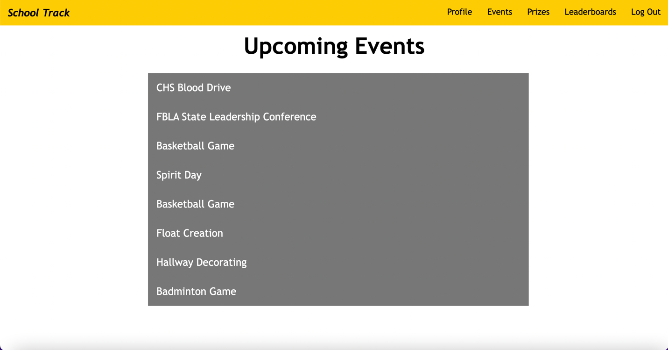

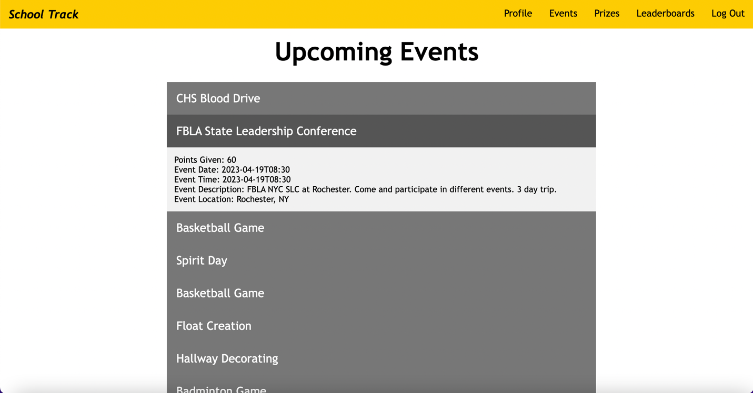

**Student Prize Page -** When the student clicks on the prizes page, they see all the different prizes. 

When you hover over one of the images, you see what winner gets that prize. The top point winner of each grade gets “Become student principle for a whole day”. The random winner has 2 potential options. If they have more than 30 points, they “Get school lunch free for three days”. If they have less than 30 points, they “get school cap free from school store”.



When you scroll down, you will be able to see the winner selection state. They will either say stay tuned, if the admin has not selected the winners, or the winners’ names, if the admin has selected the winners.

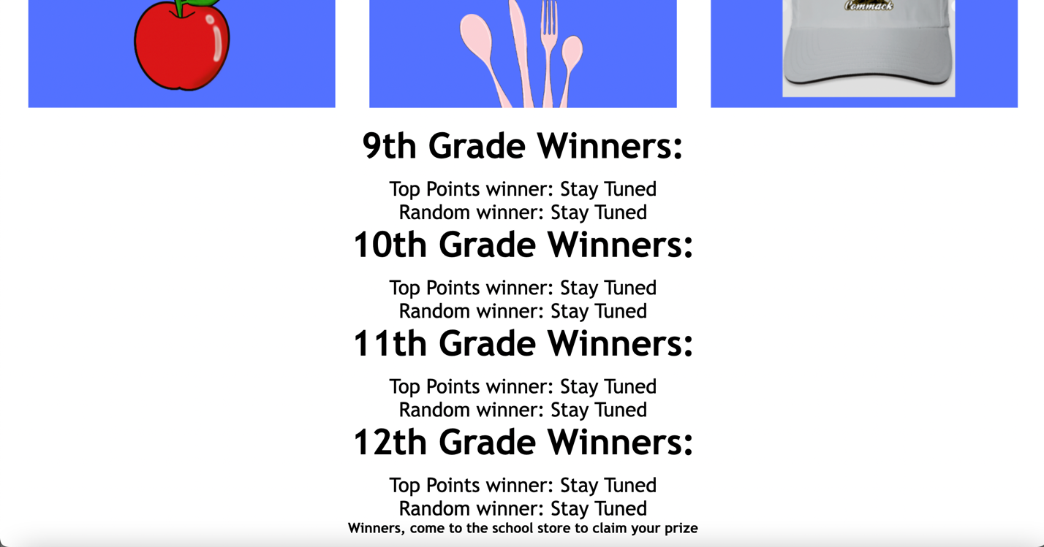

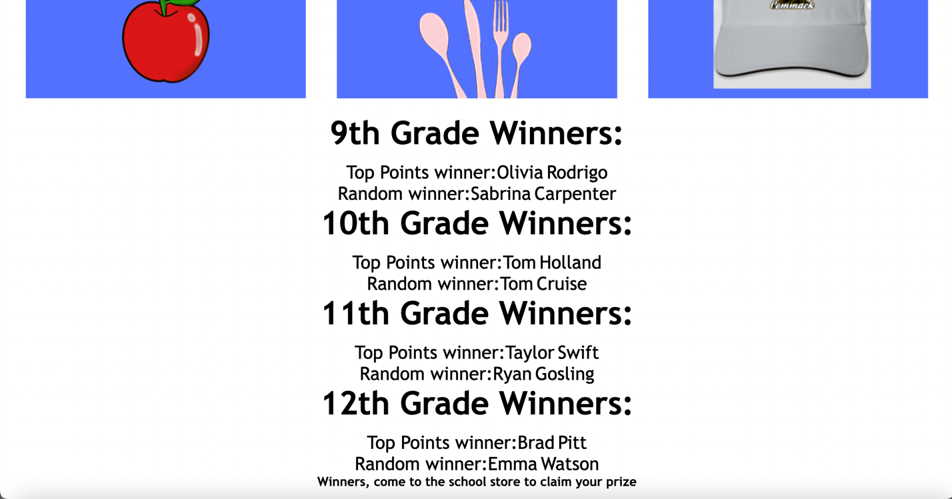

**Student Leaderboard Page** - When the student hovers over the leaderboard tab, the student has the option to click on any grade and get the leaderboard for that grade. The leaderboard also doubles as the report but gives the students a sense of competition to win the best prize. The Leaderboards are separate for each grade and order the students by points, greatest to least.

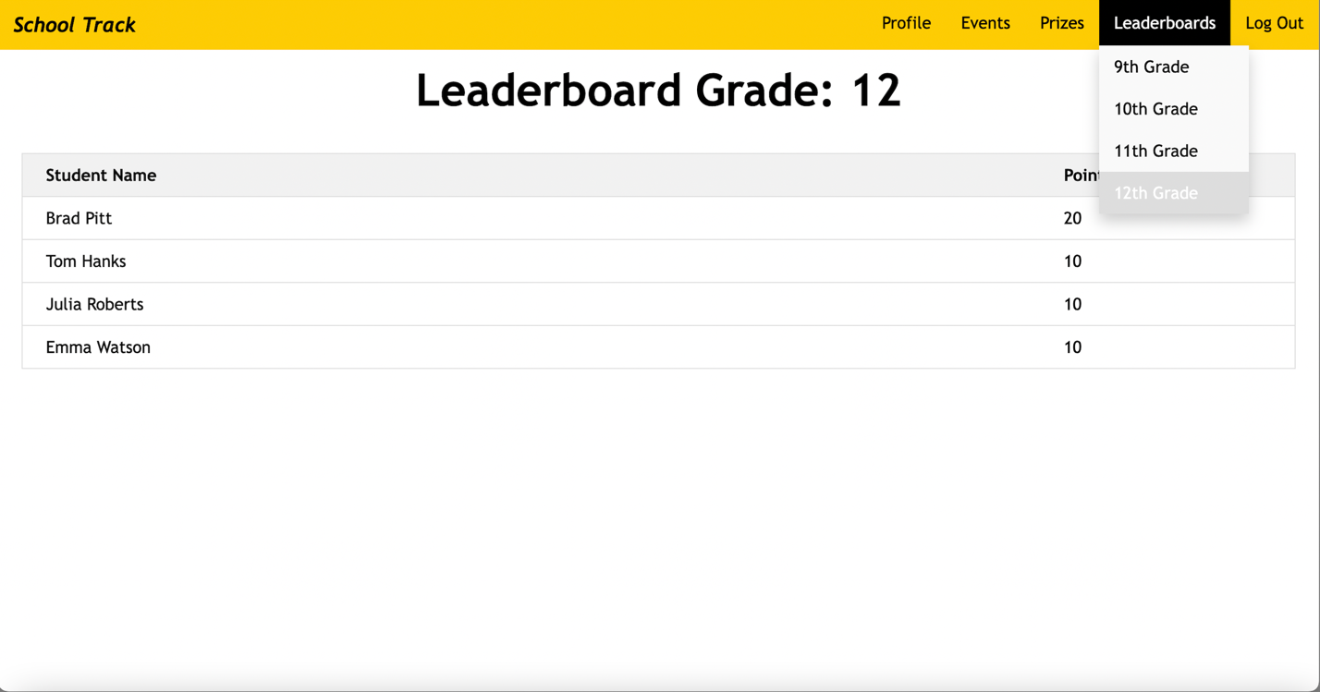

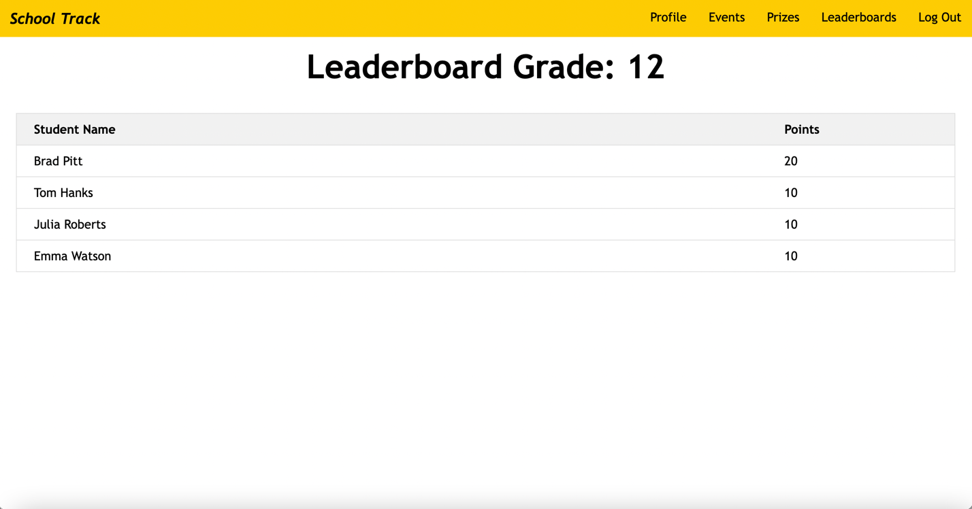

The student can then log out by clicking that button. This takes the user back to the login page.



# ADMIN USER GUIDE

The application starts on the student login page by default. The admin can click on the admin tab to get the admin login.



**Admin Login Page** - The admin can enter credentials and click login. (Username: [admin@commack.k12.ny.us](mailto:admin@commack.k12.ny.us), Password: 1234). Once the admin logs in, the program takes the admin to the admin profile page.

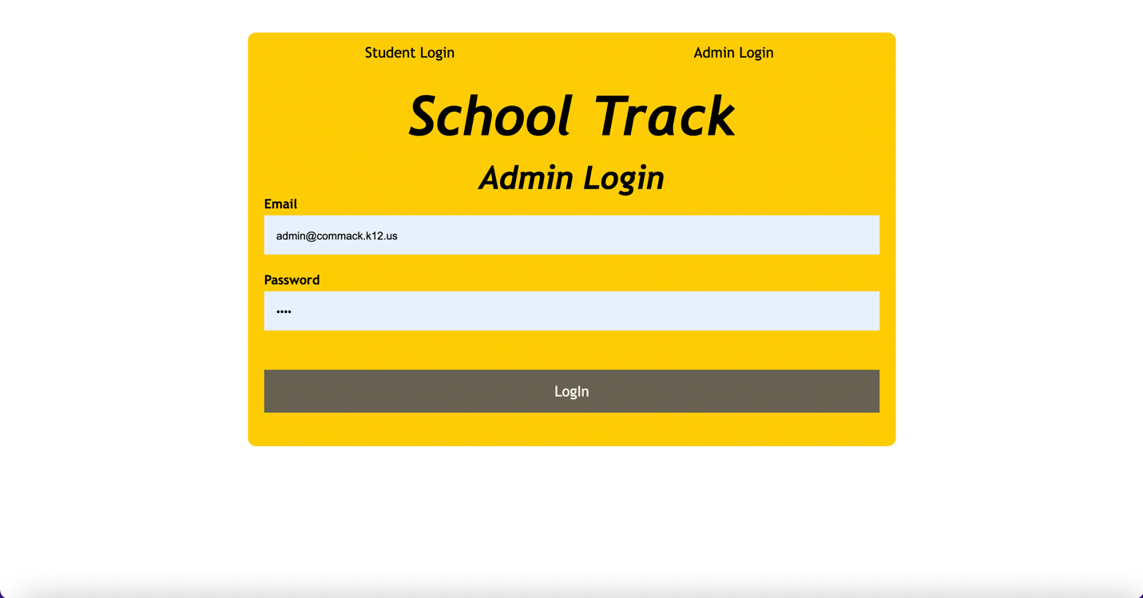

**Admin Profile Page -** This takes the admin to the admin profile. Here, the admins name is displayed and 2 buttons. Choose winners and RESET WINNERS. The admin uses these buttons to update the state of the winners for both them and the student’s page. Choose winners will make the program get the top winner from each grade and a random winner from each grade and display it on the prizes page. RESET WINNERS will make the program reset the winners and change the text on the winners page to stay tuned. This allows the admin to reset and choose new winners for every quarter.

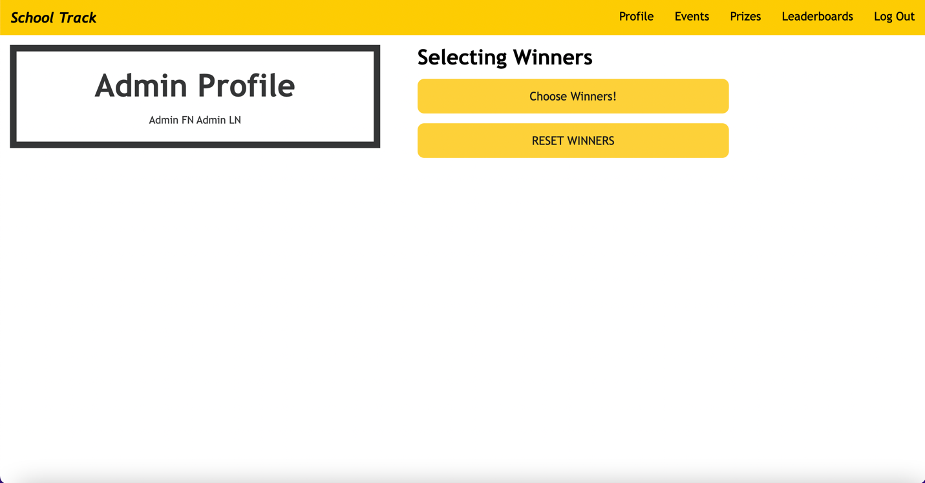

**Admin Events Page -** Next, the admin can click on the events tab. Here the admin can see all events, and they are ordered by date, the older events being in the bottom. This table is also collapsible where the admin can see the info about each event and also take the event attendance. 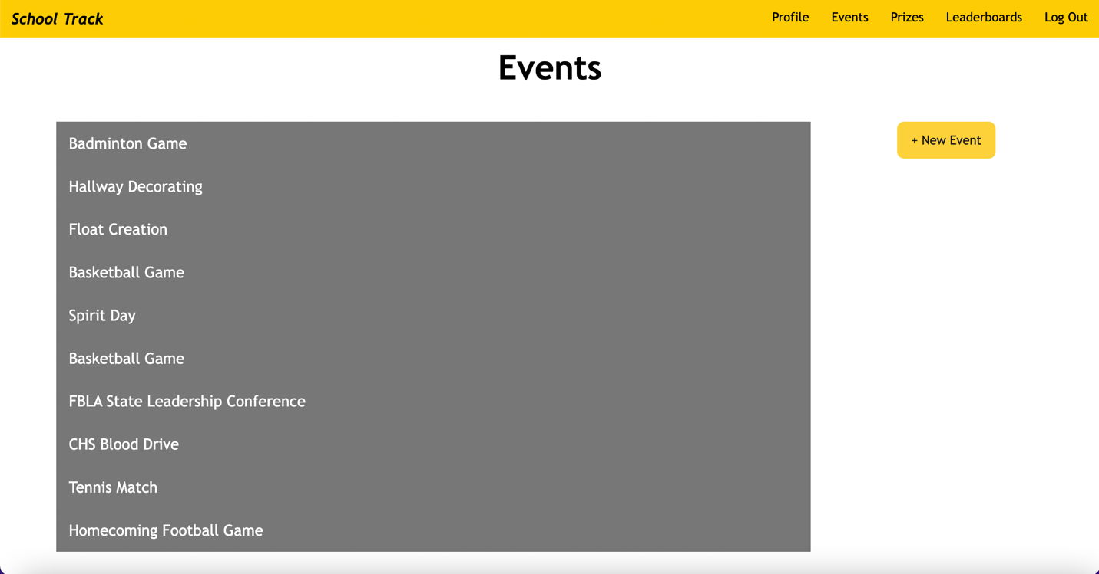

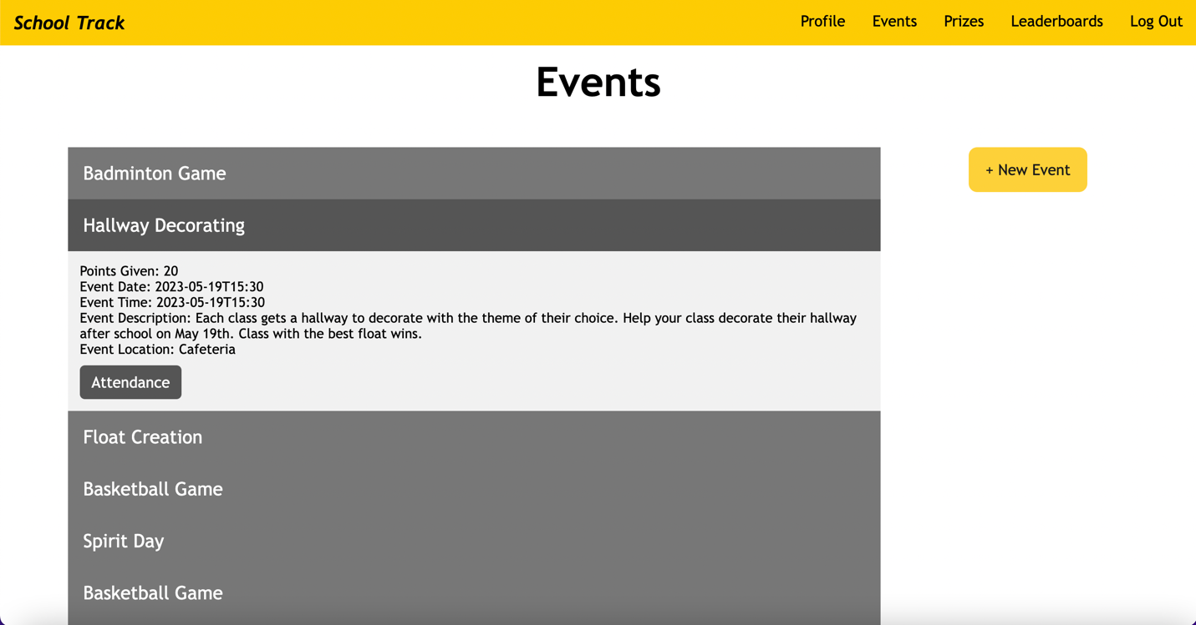

The admin can also add an event by clicking the + New Event button. This will open a pop-up form for them to input the information of this event and it will be added to both the admin’s event page and the students event page. 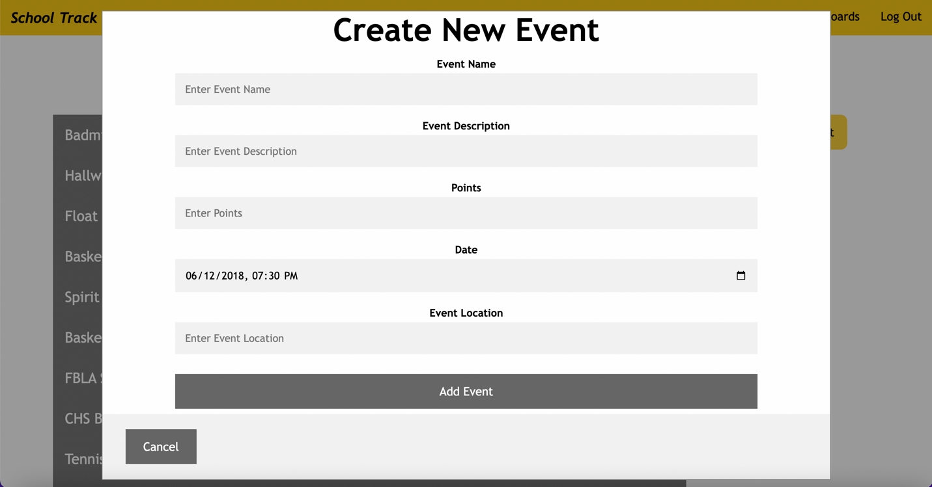

Once an event is occurring, the admin can click on that event and click on the Attendance button.



**Admin Event Check In Page** - That will take the admin to the Event Check In page. Here, the admin can check in students with the check boxes. They can also utilize the search tool to search for the names of students to facilitate the process. The admin must click on the Save Check In button once they are done to save the attendance and distribute points. This takes the admin back to the events page. 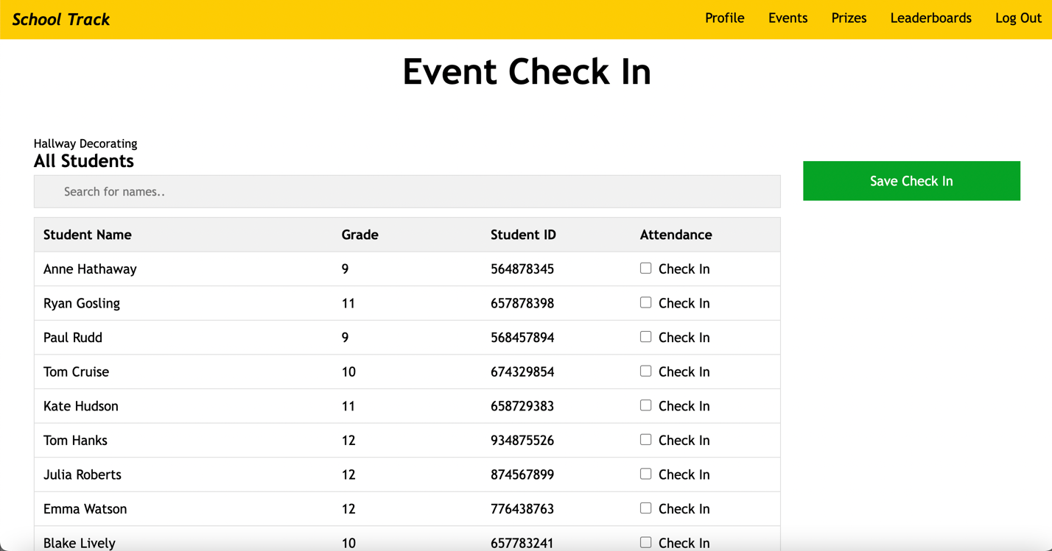

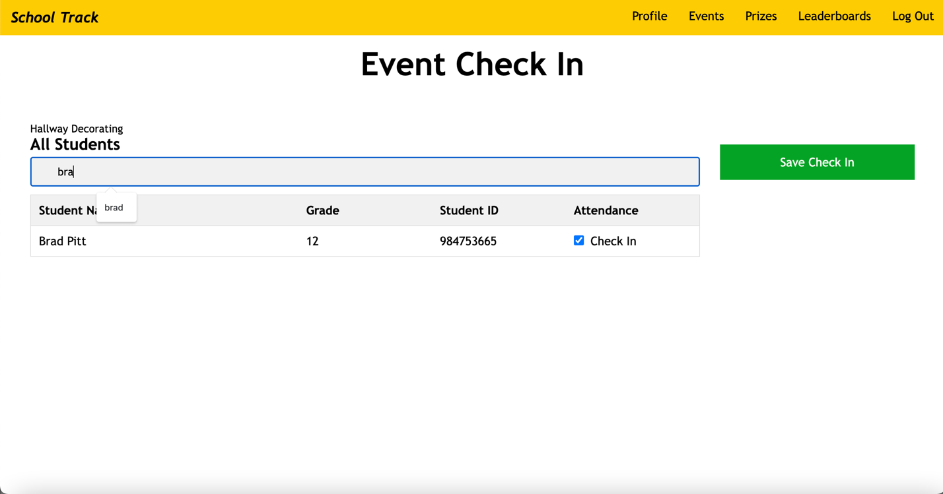

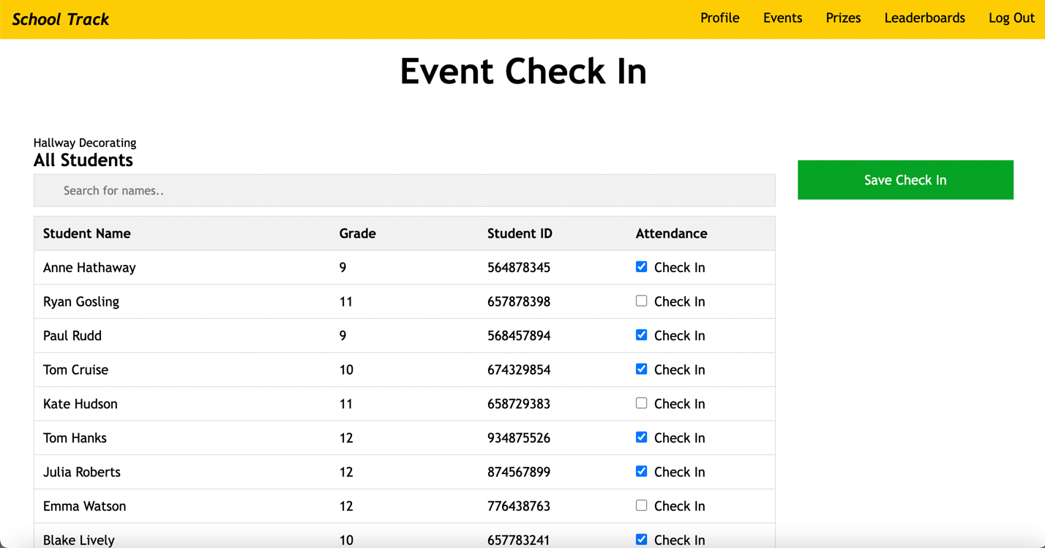

If the admin clicks on the same event again after saving the check in (to check in a late student) they will only be able to check in students that were not checked in before. Previously checked in students will say “Checked In” and will be at the bottom of the table.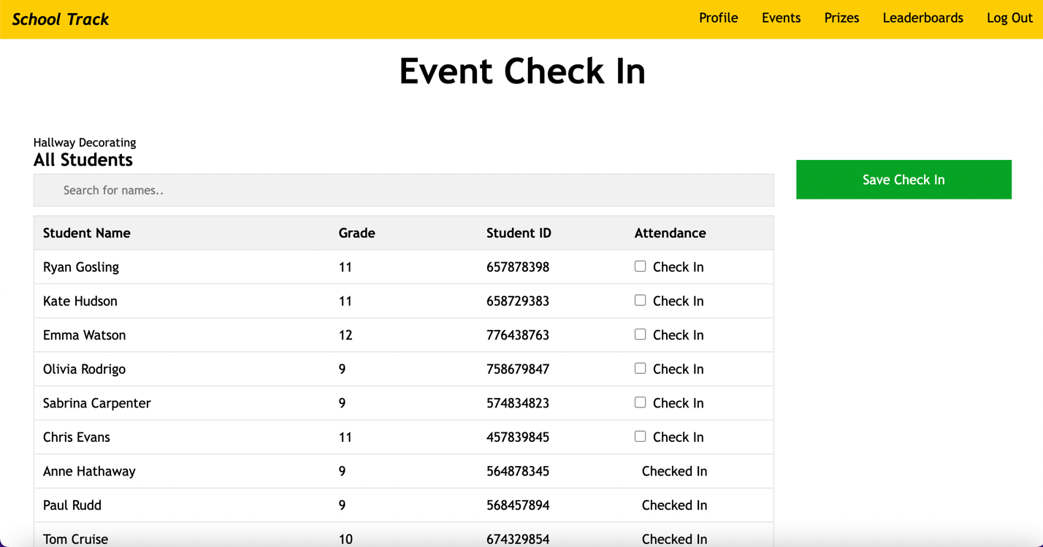

*The prizes and leaderboard pages are the same for the student and admin. Check the student guide for assistance. *